**Creating a EFS Filesystem**

***Step 1: Create an Instance Security Group***

<https://console.aws.amazon.com/ec2/v2/home#SecurityGroups>

***Create Security Group Give name, Description and your VPC and choose SSH say Create and Save SG-id***

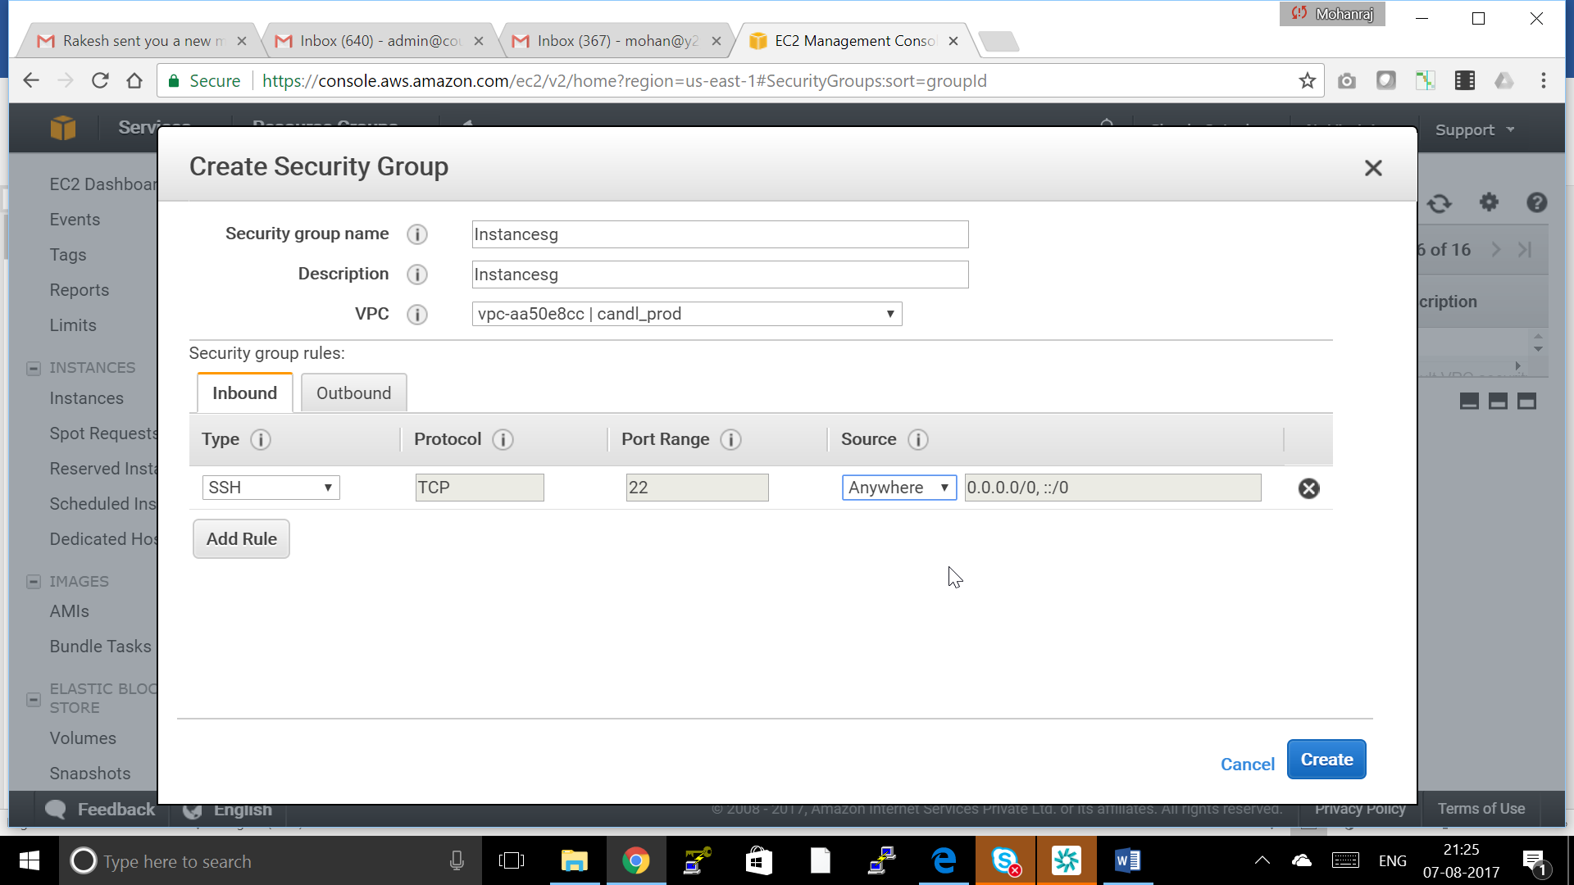

***Step 2: Create a EFS Security Group***

<https://console.aws.amazon.com/ec2/v2/home#SecurityGroups>

***Create Security Group Give name, Description and your VPC and choose 2049 TCP PORT and Destination is SG-id of instance security grouo***

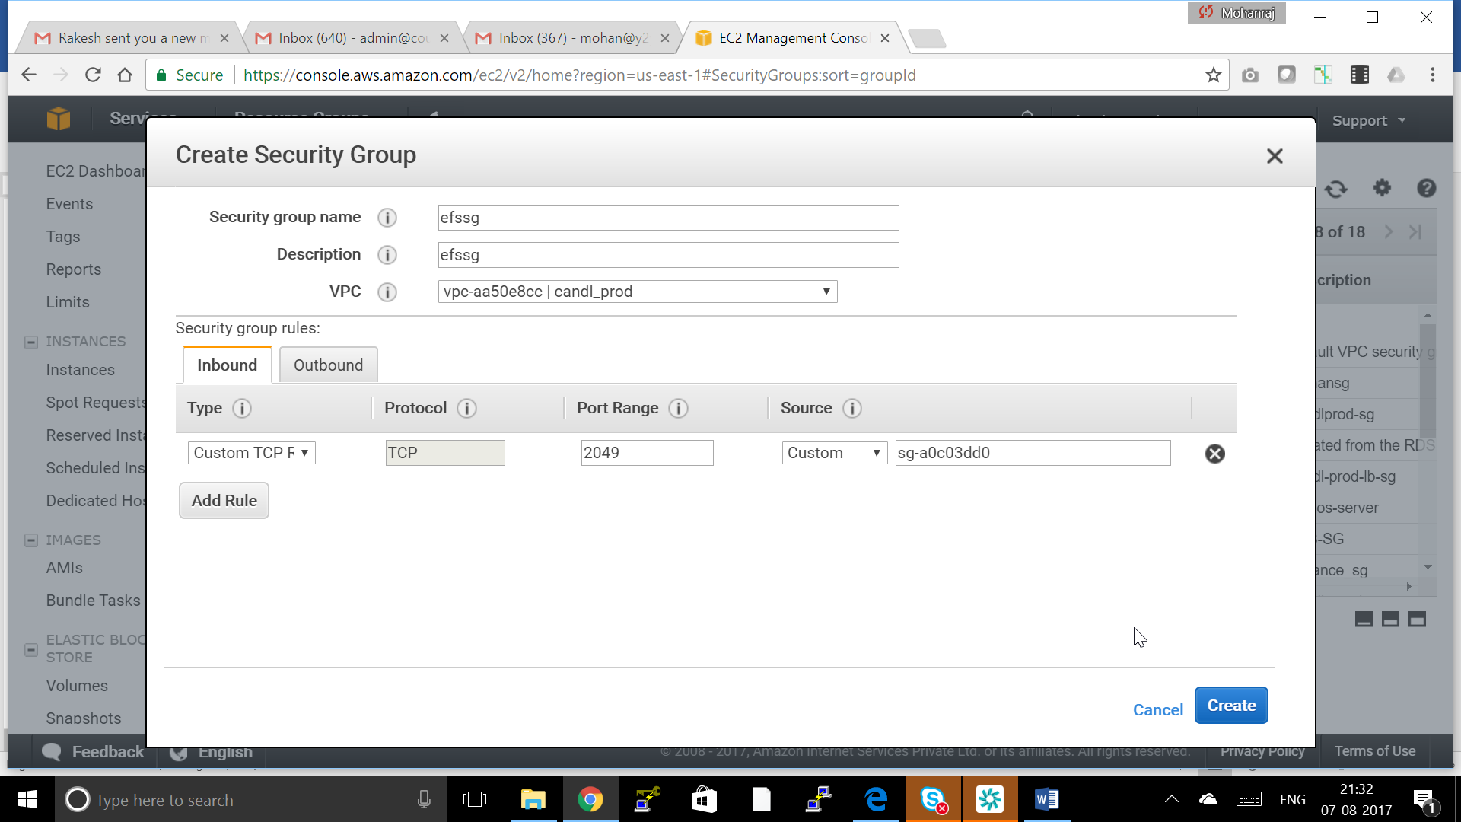

***Step 3: Create Your Amazon EFS File System***

1. Open the Amazon EFS console at <https://console.aws.amazon.com/efs/>.
2. Choose **Create File System**.
3. Choose your VPC from the **VPC** list.
4. Select the two availability zone where the Subnet are there.

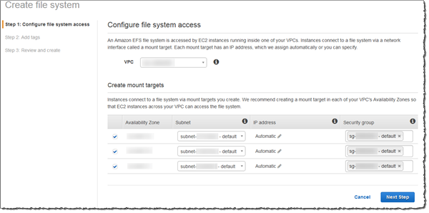

1. Choose **Next Step**.
2. Name your file system, keep **general purpose** selected as your default performance mode, and choose **Next Step**.
3. Choose **Create File System**.
4. Choose your file system from the list and make a note of the **File system ID** value. You'll need this value for the next step.

***Step 4: Create a EC2 Centos Server instance( Refer Connect to VM lab how to create a EC2 instance)***

***Note : While creating Use Instance SG as the security Group***

***Step 5: Connect to Your Amazon EC2 Instance and Mount the Amazon EFS File System***

**To connect to your Amazon EC2 instance and mount the Amazon EFS file system**

1. Connect to your Amazon EC2 instance.
2. After you've connected, install the NFS client with the following command.

$ sudo yum -y install nfs-utils

1. Make a directory for the mount point with the following command.

$ mkdir efs

1. Mount the Amazon EFS file system to the directory that you created. Use the following command and replace the *file-system-id* and *aws-region* placeholders with your **File System ID** value and AWS Region, respectively. Note that the command looks up your Amazon EC2 instance's Availability Zone using the instance metadata URI 169.254.169.254:

$ sudo mount -t nfs4 -o nfsvers=4.1,rsize=1048576,wsize=1048576,hard,timeo=600,retrans=2 $(curl -s http://169.254.169.254/latest/meta-data/placement/availability-zone).*file-system-ID*.efs.*aws-region*.amazonaws.com:/ efs

1. Change directories to the new directory that you created with the following command.

$ cd efs

1. Make a subdirectory and change the ownership of that subdirectory to your EC2 instance user. Then, navigate to that new directory with the following commands.

$ sudo mkdir getting-started

$ sudo chown ec2-user getting-started

$ cd getting-started

1. Create a text file with the following command.

$ touch test-file.txt

1. List the directory contents with the following command.

$ ls -al

As a result, the following file is created.

-rw-rw-r-- 1 ec2-user ec2-user 0 Aug 15 15:32 test-file.txt